

**LOCATION-BASED E-COMMERCE WEB APPLICATION**

**SCHOOL OF COMPUTER SCIENCE**

**BACHELOR OF SCIENCE IN COMPUTER SCIENCE**

**KEMBOI KIPTOO LOVESTRANT C026-01-1323/2019**

**6th June 2022**

# Declaration

I declare that this proposal is my original work and to the best of my knowledge has not been previously presented for a degree in any other university.

Name

………………………………………………………………………..

Signature Date

…………………………………… …………………………

This proposal has been submitted for examination with my approval as University Supervisor

Name

………………………………………………………………………..

Signature Date

………………………..……………… …………………………

# 

# Acknowledgment

I would like to acknowledge my classmates who have helped me through this project, especially whenever I needed some help and clarifications on some module creation. I also want to acknowledge my project supervisor who is our final year project lecturer as well as my supervisor. I consider myself lucky to have him as my supervisor and would like to thank him for the guidance he has offered me.

# Abstract

There are many E-commerce systems out there that are fully functional and are helping solve a lot of problems in the real world. Most of them focus on developing systems that only favor large-scale businesses that can sell to a large market of people. This large market can be all over the country, across the continent, or even across continents. This is good since people can order their products from the comfort of their homes. However, what this e-commerce system fails to consider is the needs of small-scale business people. That business personnel whose market is small and is concentrated only within their geographical location. I am talking about a three to five kilometers kilometer radius from where they are located. This kind of business is common in African countries and also in most parts of the world. This project is all about developing a system meant to provide small-scale traders with the flexibility of being able to display adverts to those who are within their geographical area.

The Location-Based Ecommerce system is a web-based application that enables a user to be able to view adverts from within and make orders, do purchases and also be able to communicate with the buyers.

This system is developed with PHP as the backend language, HTML, CSS for the front end, BOOTSTRAP for responsiveness, and firebase for the database. There is also a diagram demonstrations with the lucid chart for the UML drawings.

The main components of the system is the authentication part which will involve the Registration module, the Sign-in module, and the Reset password modules just in case a user forgets his or her password. After a successful authorization to the system, the system grants the user the session to operate on. It will also prompt the user to turn on location and allow the system to use their location. Inside the website dashboard, a user is displayed with adverts that are within him or her. They can make an order or chat with the seller in case they need further inquiries on the product.

A user also has an option of creating a business account where the system will grant them an option of creating an advert, deleting an advert, and changing advert coordinates.

Users also have an option of logging out in case they are done using the system. At this point, the session variables is killed and the user returned to the index page.

The geolocation feature works such that as the trader creates an advert, his or her coordinates is used as the central reference point from the potential buyers who are the users of the system in this case. In the case of the scenario where the traders keep changing location, they also have an option of changing advert coordinates which will be the new reference point to the potential buyers.

This project will impact a lot of people because there are millions of small-scale traders in our society who are not favored by the current existing e-commerce platforms.

Table of Contents

Declaration ii

Acknowledgment iii

Abstract iv

LIST OF FIGURES vi

LIST OF TABLES vii

Chapter One: Introduction 1

1.0 Background 1

1.1 Problem Statement 2

1.2 Objectives 3

1.2.0 General objective 3

1.2.1 Specific objectives 3

1.3 Research question 3

1.4 Justification 3

1.5 Scope 3

Chapter Two: Literature Review 4

2.0 Introduction 4

2.1 Case One: Amazon retail Platform in the USA. 4

2.2 Case Two: Alibaba E-commerce platform in China 5

2.3 Case Three: Jumia Retail Platform in Kenya 5

2.5 Conclusion 6

Chapter Three: Methodology 7

3.0 Introduction 7

3.1 Fact Finding Techniques 7

3.1.1 Unstructured Interviews 7

3.1.2 Observations and Measurements 7

3.2 Software Design – Software Development procedures 7

3.3 Waterfall methodology 9

Phases in the Waterfall Model 9

Chapter Four: ANALYSIS AND DESIGN 10

4.1 Introduction 10

4.2 Requirements Analysis 11

Functional requirements 11

Non-functional requirements 12

4.2.1 Data Collection Results 12

4.2.2 Results for interviews 12

4.3.0 Results for questionnaires 13

4.4 System analysis 19

4.4.2 Activity diagram 19

4.4.2 Use case 20

Data flow diagram 21

4.5 System Design 22

4.5.1 Interface Design. 22

4.5.1.1 Sign in Page. 23

4.5.1.2 Sign up Page. 23

4.5.1.3 Reset Page. 24

4.5.1.4 Home Page. 24

4.5.1.5 Profile Page. 25

4.5.1.6 Create new Business account Page. 25

4.5.1.7 Business accounts Page. 26

4.5.1.8 Advert Creation Page 27

REFERENCES: 27

# LIST OF FIGURES

Figure 1 Object-oriented development life cycle 8

Figure 2: Waterfall model 10

Figure 3 Results for interviews 13

Figure 4 Results for question 1 14

Figure 5 Results for question 2 15

Figure 6 Results for question 3 16

Figure 7 Results for question 4 17

Figure 8 Results for question 5 18

Figure 9 Results for question 6 19

Figure 10 Activity diagram 20

Figure 11 Use case diagram 21

Figure 12 Data Flow Diagram 21

# LIST OF TABLES

*Table 1: Results for interviews* 13

Table 2 Results for question 1 13

Table 3 Results for question 2 14

Table 4 Results for question 3 15

Table 5 Results for question 4 16

Table 6 Results for question 5 17

Table 7 Results for question 6 18

# Chapter One: Introduction

## Background

Globally, e-commerce is a $2 trillion industry. It is expected to grow even more in the next few years. Many big companies, such as Amazon and Walmart, are investing heavily in e-commerce systems. The vast majority of e-commerce transactions take place through online stores operated by large retailers. However, small businesses also use e-commerce systems to sell their products online. These systems allow small businesses to reach a global audience and increase profits. The beginning of commerce systems dates back to the early days of the internet. However, e-commerce systems took off in the 2000s. This was because online retailers began to use these systems to manage their customer relationships and inventory. Ecommerce systems are complex databases that contain information about products, customers, and orders. They also allow retailers to track sales and marketing data.

The key features of an effective e-commerce system include:

-A well-designed user interface that is easy to navigate

-A secure system that protects customers’ personal information

-A system that can handle large volumes of traffic

-A well-developed shipping and delivery system

-An effective marketing strategy that targets customers who are likely to buy products from the retailer

Ecommerce systems are used by large retailers and small businesses alike. They provide a powerful way for businesses to reach a global audience and increase profits. If you're looking to start or expand your business, an e-commerce system is a must-have. The leading country in terms of e-commerce in China. In 2018, the Chinese market accounted for almost half of all online retail spending. This growth is expected to continue in the years to come. Location-based e-commerce systems allow businesses to sell products directly to customers who are located near them. This is a great way for small businesses to reach out to potential customers and increase sales.

In Africa specifically Kenya there is the use of e-commerce systems that allow customers to purchase goods and services from local businesses. Some of the most popular systems include:

-MyKadha: MyKadha is a mobile app that allows users to make payments and manage their finances.

-Zaarly: Zaarly is an online marketplace that allows small businesses to sell products and services.

-ShopQwikki: ShopQwikki is a mobile app that allows customers to buy products from local businesses.

-Bizimama: Bizimama is an online marketplace that allows small businesses to sell products and services.

-Ushahidi: Ushahidi is an online platform that allows users to report occurrences such as road accidents, fires, and riots.

There are also several local e-commerce systems that don't use apps. Some of these systems include:

-Gifti: Gifti is a website that allows customers to buy and send gifts.

-Nakumatt: Nakumatt is an online marketplace that allows small businesses to sell products and services.

-Kijiji: Kijiji is a classified ads site that allows local businesses to sell goods and services.

-Maisha Mall: Maisha Mall is a physical mall located in Nairobi, Kenya that offers shoppers access to a wide range

## 1.1 Problem Statement

There are many E-commerce systems out there that are fully functional and are helping solve a lot of problems in the real world. Most of them focus on developing systems that only favor the large-scale businesses that can sell to a large market of people. This large market can be all over the country, across the continent, or even across continents. This is good since people can order their products from the comfort of their homes. However, what this e-commerce system fails to consider is the needs of small-scale business people. That business personnel whose market is small and is concentrated only within their geographical location. I am talking about a three to five kilometers kilometer radius from where they are located. This kind of business is common in African countries and also in most parts of the world. This project is all about developing a system meant to provide small-scale traders with the flexibility of being able to display adverts to those who are within their geographical area.

## 1.2 Objectives

### 1.2.0 General objective

To be able to develop an e-commerce system that can enable the small scale traders to advertise their products within a small area because their market will only lie within.

### 1.2.1 Specific objectives

1. To provide a platform for small scale businesses to advertise their products to markets within.
2. To develop a platform that will enable buyers from a crowded market to easily find products to buy and save time of going round shop to shop.
3. To come up with a way we can accommodate the smallest business personnel out there with the changing technology.

## 1.3 Research question

1. How can we develop an algorithm that is going to calculate the distance in KM between two users in a session, and with the help of their coordinates?
2. How can we use the algorithm to develop the e-commerce platform to link the buyers and sellers within for them to trade?
3. Can we implement an authentication system for this web-based e-commerce system, how can I use the user details to assign session variables and recognize users all over the system?
4. How do we integrate payment methods for this e-commerce method?

## 1.4 Justification

To be able to transform the smallest businesses in the society and be able to enable them to enjoy the growth in technology, there is a need to develop this system and provide them with a better platform that fits the size of their market rather than leaving them behind as if they don’t matter.

## 1.5 Scope

This project is expected to take roughly six months. The main areas of implementation are the authentication section, the geolocation algorithm, the chat section for the buyer and seller to communicate, and the payment system API integration in the website. The project budget is 2500 Kenya Shillings. 1500 KES was allocated for the hosting space and the rest for the domain.

# Chapter Two: Literature Review

## 2.0 Introduction

There are more than 7.4 million micro-businesses in Kenya currently. This number keeps on increasing day after day. These small-scale businesses deal with the basic needs of most of the people in the country which include, food, rental for shelter, and clothing as well. We have more than 50 million smartphone users in the country currently. This means that the country is rapidly shifting towards a technological era. As a result of that, there is a need to provide a platform for the small-scale businesses out there to be able to reach the majority of the customers easily through the internet. By developing this system we will be able to solve that particular problem.

## 2.1 Case One: Amazon retail Platform in the USA.

Amazon is one of the most popular online marketplaces used by both individuals as well as businesses, and the site is available in many different countries and languages. Amazon Kindle is one of its most popular products as well as the Amazon app store. Lastly, Amazon offers software and infrastructure solutions for businesses and individuals.

Amazon was begun in 1994 in Seattle Washington by Jeff Bezos, and was initially little more than an online bookstore. From those humble beginnings, Amazon has become the largest online e-commerce retailer, and one of the most powerful brands in the world. Not only has it expanded its offerings of goods and services, but it also participates in the streaming video marketplace, the cloud computing marketplace, and most recently Amazon has entered into banking.

Not only is Amazon the most valuable internet retailer in the world, but it is also the most valuable retailer period, having surpassed Wal-Mart back in 2015.

Amazon has a storefront website for over a dozen different countries, and ships to nearly every country in the world. It also hosts the retail websites of brands such as Sears Canada, Marks & Spencer, Lacoste, and others. It also owns over 40 subsidiary brands such as Zappos, Diapers.com, Goodreads, IMDb, and many more.

They are a lot of nice things about amazon as discussed above, however, what Amazon fails to consider is the fact that not everyone can run a large-scale business, and not everyone can run a large-scale retail business. Most people especially in third world countries like Africa have the smallest business earning less than 10 dollars per day. That is the type of business I would like to focus on.

## 2.2 Case Two: Alibaba E-commerce platform in China

Alibaba was [founded in 1999](http://www.bloomberg.com/infographics/2014-09-05/alibaba-ipo.html) by former English teacher [Jack Ma](https://www.bloomberg.com/news/terminal/OJLEMF6S972J), who scraped together $80,000 from 80 investors to start an online marketplace for Chinese companies. He became the [richest man](http://www.bloomberg.com/news/2014-08-27/jack-ma-emerges-as-china-s-richest-man-before-alibaba-ipo.html) in China and his estimated net worth has topped [$47 billion](http://www.bloomberg.com/billionaires/2015-11-09/cya/aaaga).

Alibaba’s growth story has continued since its record [$25 billion](http://www.bloomberg.com/news/2014-09-22/alibaba-s-banks-said-to-increase-ipo-size-to-record-25-billion.html) initial public offering in New York in 2014 and it is now ranked among the world's top 10 companies in terms of market value. An [inquiry](http://www.bloomberg.com/news/articles/2016-05-25/alibaba-undergoing-sec-investigation-over-accounting-practices)into Alibaba's accounting [methods](http://hsprod.investis.com/ir/alibaba/2016_Alibaba_20-F.pdf) and the company's return to a[U.S. government list](https://ustr.gov/sites/default/files/2016-Out-of-Cycle-Review-Notorious-Markets.pdf) of the world's [largest destinations for fake goods](https://www.bloomberg.com/news/articles/2016-12-21/u-s-again-labels-alibaba-a-notorious-market-for-knock-offs) have wiped off some of the shine, but not so much for investors: Its shares reached a record in 2017, trading at more than two-and-a-half times the IPO price. Facing competition from the likes of [Tencent Holdings Ltd.](http://www.bloomberg.com/quote/TCEHY:US)and [Baidu Inc.](http://www.bloomberg.com/quote/BIDU:US), Alibaba is investing heavily in reaching customers through smartphones and tablets, as well as [cloud computing](http://www.bloomberg.com/news/articles/2015-10-09/alibaba-opens-second-u-s-data-center-in-1-billion-cloud-push)and [virtual reality](http://www.bloomberg.com/news/articles/2016-03-17/alibaba-taps-virtual-reality-for-3d-online-shopping-experience). It owns stakes in Southeast Asian e-commerce site [Lazada](http://www.bloomberg.com/news/articles/2016-04-12/alibaba-to-pay-1-billion-for-control-of-lazada-e-commerce-site)and ride-sharing program [Lyft](http://www.lyft.com/), has its mobile operating system, and is leasing spectrum from state-owned phone companies to offer mobile voice and data packages. It also has a stake in a leading Chinese [soccer team](http://www.bloomberg.com/news/articles/2014-06-05/evergrande-rises-on-alibaba-soccer-stake-report-hong-kong-mover), became a top [Olympic Games sponsor](https://www.bloomberg.com/news/articles/2017-01-19/alibaba-will-put-its-technology-to-the-test-on-an-olympian-stage), and bought Hong Kong’s century-old [South China Morning Post](http://www.bloomberg.com/news/articles/2015-12-14/alibaba-buys-south-china-morning-post-assets-for-266-million) newspaper. Its investments in Chinese department store operator Intime Retail Group and hypermarket giant Sun Art Retail Group Ltd. were among more than 70 deals worth a combined $29 billion in 2016 and 2017. At the same time, its customer base has spread to [countries as diverse](http://www.bloomberg.com/news/2014-11-10/alibaba-adds-brands-to-drive-promotion-that-dwarfs-cyber.html) as Brazil and Russia. A tussle with the Chinese government over charges of bribery and toleration of [counterfeit goods](http://www.bloomberg.com/news/articles/2015-01-28/china-accuses-alibaba-of-lacking-proper-oversight-of-merchants), while quickly patched up, was a reminder of the risks of doing business in a one-party state. And the probe by the U.S. Securities and Exchange Commission has underlined [concern](http://www.bloomberg.com/gadfly/articles/2016-05-26/alibaba-may-yet-prove-a-greek-tragedy-for-hedge-funds)over what one analyst called Alibaba’s “[unusual](http://www.bloomberg.com/news/articles/2016-05-25/alibaba-undergoing-sec-investigation-over-accounting-practices)” accounting practices.

Still, the history of Alibaba and how it operates does not favor the smallest businesses ever. For those businesses whose market lies within, I am talking of a market lying within the 3 KM range. I intend to solve this negligence in the e-commerce platform systems.

## 2.3 Case Three: Jumia Retail Platform in Kenya

Jumia, Kenya’s no. 1 online retailer opened its doors in May 2013. Its aim and vision were to become the one-stop shop for retail in Kenya with the implementation of best practices both online and offline.

Initially, it began with only 3 employees and today boasts of about 1000 employees working smart to ensure that customers get value for money

It is important to note that Jumia Kenya is a subsidiary of Jumia whose headquarters are in Nigeria. It is also present in countries such as Egypt, and Morocco among others.

Today it boasts of being the largest online retail store in Kenya, second only to none. In Kenya, it is headquartered in Westlands, Nairobi.

This online retail store depends on thousands of vendors who sell on the platform. The vendors are the actual owners of the products listed on the website. Jumia Kenya only offers a platform to sell the products. That is why it is not uncommon to find the same product listed at different prices! This simply points to the fact that different vendors list the same product.

The fact that Jumia is offering its platform for retailers to sell on it doesn’t eradicate the fact that there are still the smallest traders in Kenya who are left out of the business of sales digitalization. This has to stop because the smallest Kenyan market is in the hands of the smallest businesses. We can’t leave them behind, instead, we need to develop a platform to enable them to be a part of the internet as well.

## 2.5 Conclusion

From the above e-commerce platforms discussed it is clear enough that there is a gap in the E-commerce platforms that are being used all over the world. The is the issue of favoritism for the large-scale businesses; those that can raise huge amounts of capital. I intend to solve this problem and provide the platform for the smallest retailers to be able to market their products to their market which is within.

# Chapter Three: Methodology

## 3.0 Introduction

To achieve the goals and objectives of this project, this chapter discusses the methods which were adopted in this research and explain clearly why some methods were preferred over others. The methods that I used include observation, questionnaires and oral interviews.

## 3.1 Fact Finding Techniques

Various data was needed to ensure the successful completion of this project. Several methods will be used to collect the required data about the current entry registration process of vehicles. The following techniques were applied.

### 3.1.1 Unstructured Interviews

I personally interviewed a few traders who are targeted by this project and who own the smallest businesses around Dedan Kimathi University to listen to their views concerning the platform. Seventy five percent of them supported the idea of building location based e-commerce system that will enable them boast their businesses. However twenty five percent of them thought that the idea was not much useful because most African traders don’t have the digital phones that will enable them advertise their products online.

### 3.1.2 Observations and Measurements

The application is hosted after successfully developed and adverts will be created from the application then the geolocation algorithm will be tested from different already identified points in the school. This feature will enable proper evaluation of the geolocation feature. The fixed mile radius that the system is currently using is the three mile radius. This displays adverts to those close

## 3.2 Software Design – Software Development procedures

This project adopts an Object-oriented System Development methodology. This methodology is a design strategy where everything is thought of as “things” or “objects” instead of functions or operations. The system will be made up of interacting objects which will maintain their local state and provide operations on the information state.

This methodology is more cost-effective and is a much faster way of developing systems and software. It cuts the time of development, and overhead and also enables the developers to make reusable, easily maintainable, and reliable applications. In addition to this, it offers a new way, which is a much more powerful model of writing software. Object-oriented programming (OOP) allows us to subdivide a problem into several objects and then build functions and data around these objects. It ensures that the system is transformed and refined through the analysis, design, code, and test phases. All the details and any modifications are added in successive iterations and incremental releases as the software are delivered.

The object-oriented development life cycle involves five phases as illustrated in the Figure below.

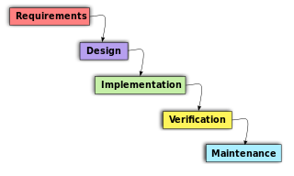

Figure 1 Object-oriented development life cycle

These phases as described below:

1. Requirement analysis – This is where all the required features of the system are collected and analyzed.
2. Design – This phase involves the preparation of the technical design requirements and features of these requirements specified in detail. These features include; the database used, functionalities and features, security procedures, and the hardware and the systems required.
3. Implementation – The designs done in the previous stage are translated to machine-readable form using specific programming languages.
4. Verification – After the application has been developed, different testing occurs including performance and integration testing. Then user acceptance testing is done by end-users to make sure that the systems meet their expectations. When any defect is found, more work is done in the analysis, design, or coding.
5. Maintenance – The software, after it has passed user acceptance, will be maintained from time to time by updating the code as changes occur in the end-user environment or technology.

## 3.3 Waterfall methodology

This system also used waterfall technique in terms of planning of the project till implementation.

Waterfall methodology is a breakdown of project activities into linear sequential phases, where each phase depends on the previous phase. In this methodology the outcome of one phase becomes the input of the next phase. It is the most suitable for this project because it is a step by step techniques. I needed to first of all implement the authentication which will lead to giving users sessions and capture their locations which will be used to determining the kind of adverts that are within them.

### Phases in the Waterfall Model

**Requirement gathering and analysis:** this is the first phase which involves understanding what needs to design and what is its function, purpose, etc. Here, the specifications of the input and output or the final product are studied and marked.

**System Design:** The requirement specifications from the first phase are studied in this phase and system design is prepared. System Design helps in specifying hardware and system requirements and also helps in defining overall system architecture. The software code to be written in the next stage is created here.

**Implementation:** With inputs from system design, the system is first developed in small programs called units, which are integrated into the next phase. Each unit is developed and tested for its functionality which is referred to as Unit Testing.

**Integration and Testing:** All the units developed in the implementation phase are integrated into a system after testing of each unit. The software designed, needs to go through constant software testing to find out if there are any flaw or errors. Testing is done so that the client does not face any problem during the installation of the software.

**Deployment of System:** Once the functional and non-functional testing is done, the product is deployed in the customer environment or released into the market.

**Maintenance:** This step occurs after installation and involves making modifications to the system or an individual component to alter attributes or improve performance. (S.Balaji & Murugaiyan, 2012; Moses Gitari, 2021) Source: (sim, 2009)

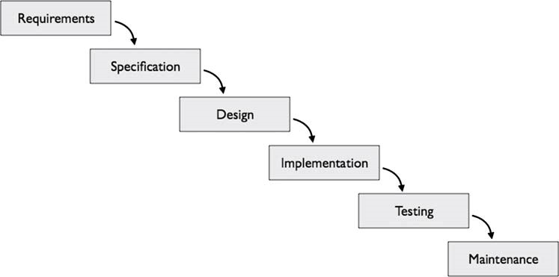

Figure 2: Waterfall model

**Advantages of waterfall methodology**

1. Allows easy testing and analysis.
2. It is understandable and easy to use due to rigidity of the model since each phase has specific deliverable and review process.

# Chapter Four: ANALYSIS AND DESIGN

## 4.1 Introduction

System analysis is a process of collecting and interpreting facts, identifying the problems and decomposition of a system into its components. System analysis is conducted so as to help in identifying objectives and to ensure all the components of the system work efficiently. Basically, system analysis specifies what the system should do.

System design is a process of planning a new system or replacing an existing system by defining its modules to satisfy the specific requirements. System design focuses on how to accomplish the objective of the system.

System analysis and design mainly focuses on:

* Systems
* Processes
* Technology

## 4.2 Requirements Analysis

Any function, constraint, or property that the system must have, meet, or satisfy to achieve its goal is referred to as a requirement. The purpose of the analysis is to come up with the most important requirements.

The system's primary requirements were gathered during the data collection stage. For the researcher to fully understand the current procedure, the main stakeholders of the system were interviewed as they went about their daily tasks.

The system requirements provide the functional and Non-functional requirements of the system. Design of the system is carried out according to the features and operations of the system which includes the user interface, UML diagrams and other documentation.

### Functional requirements

A user visits the location based web application, creates an account by signing up and signs in then he or she can now access the dashboard where he can see the adverts that are within a radius of three kilometres. The user can then add to cart and order the product or chat with the seller in case he or she needs more clarification. A user also has the option of creating a business account any time he feels like and can create adverts of his or her products.

### Non-functional requirements

This involve the attributes the system has.

1. User friendly - this involve how the user interacts with the system. This system is user friendly as a blind and visually impaired person can fully interact with it because it uses voice inputs and outputs.
2. Reliability - this involve the output the system has in various conditions. This system is reliable as it produces similar results under different lighting conditions.
3. Maintainability - this involve the ease with which the system can be modified to correct faults. Maintaining this system will be easy as it involves fewer modules.
4. Efficiency - signifies higher level of performance with a least amount of inputs. This system requires less than 5 seconds camera scan of a note to identify its value.

## 4.2.1 Data Collection Results

From the interview and observation:

1. The business people who are mostly sole proprietors in this case go about moving from place to place as they sell their products.
2. In some crowded locations for example in Nyeri town, the business personnel shouts loud to advertise their products to the passersby.

This traditional method was not efficient enough and needed to be worked on, it needs to be replaced by a better system that accommodates their small market. The process of customers having to go manually from shop to shop to find the right product in a town is something that has to be put in the past. With this location-based E-commerce system, such problems are solved.

### 4.2.2 Results for interviews

I interviewed 4 business persons who are dealing with small scale businesses around our school and also interviewed 4 other people who are regular consumers to those small scale business products. The following is the results that I managed to collect in table and in a flow chart.

|  |  |  |
| --- | --- | --- |
| Number of people interviewed | Proposed to the idea | Opposed to the idea |
| 8 | 6 | 2 |

*Table 1: Results for interviews*

Figure 3 Results for interviews

### Results for questionnaires

I did an online survey with the help of google questionnaires asking people the following six questions. The following is an analysis of their responses in tables and pie chart screenshots.

Question 1: Do you know how e-commerce system works?

Table 2 Results for question 1

|  |  |
| --- | --- |
| Those who said YES | Those who said NO |
| 20 | 2 |

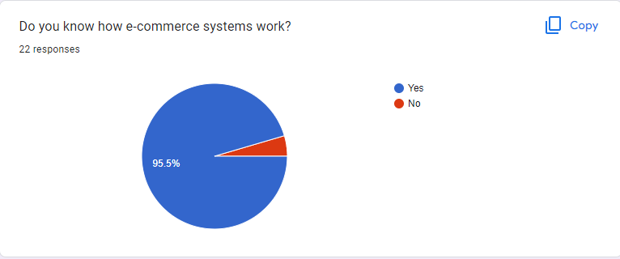

Figure 4 Results for question 1

Question 2: Have you ever ordered a product through an e-commerce system before?

Table 3 Results for question 2

|  |  |
| --- | --- |
| Those who said YES | Those who said NO |
| 18 | 4 |

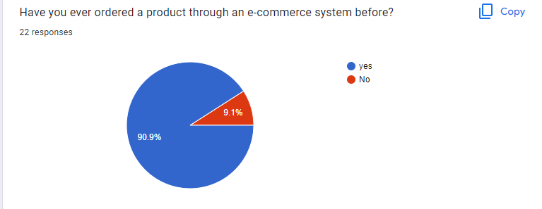

Figure 5 Results for question 2

Question 3: Do you think small-scale traders should have platform to advertise their products for buyers within their geographical area? (The likes of meat sellers and Mama mboga)

Table 4 Results for question 3

|  |  |
| --- | --- |
| Those who said YES | Those who said NO |
| 18 | 4 |

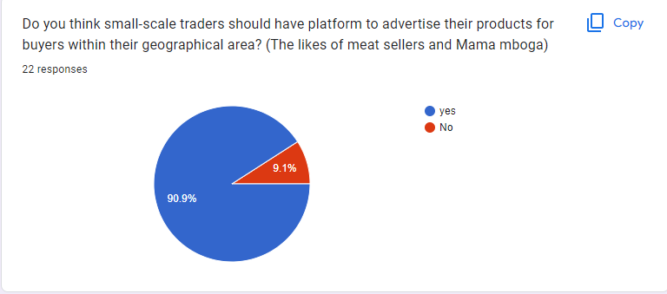

Figure 6 Results for question 3

Question 4: What do you think of an ecommerce system that is meant for micro businesses out there, such that small scale businesses can display their ads within a geographical area of 3 KMs radius between buyer and seller?

Table 5 Results for question 4

|  |  |  |  |
| --- | --- | --- | --- |
| Highly necessary | Necessary | Less Necessary | No need of having it at all |
| 13 | 7 |  | 2 |

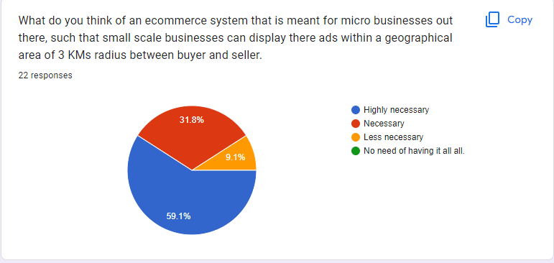

Figure 7 Results for question 4

Question 5: Do you think the current existing ecommerce systems have neglected the needs of small businesses and instead focus on large businesses whose market cover a large geographical area?

Table 6 Results for question 5

|  |  |
| --- | --- |
| Those who said YES | Those who said NO |
| 19 | 3 |

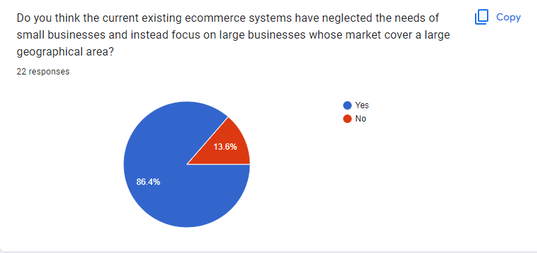

Figure 8 Results for question 5

Question 6: Assuming you have a small business and your market lies within, would you prefer to have a platform to advertise your products to customers who are within you.

Table 7 Results for question 6

|  |  |
| --- | --- |
| Those who said YES | Those who said NO |
| 16 | 0 |

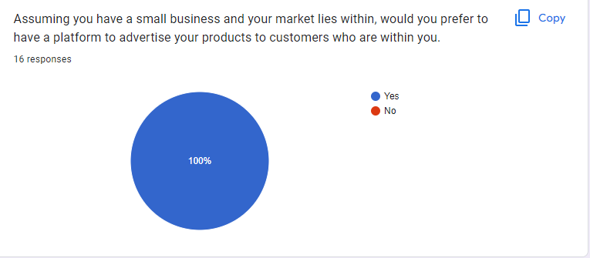

Figure 9 Results for question 6

From the above data analysis it is clear that most people are familiar with ecommerce system and most people think that it is a good idea to have location based e-commerce system. This will solve the problem that is incurred by the small scale businesses in terms of marketing.

## 4.4 System analysis

### 4.4.2 Activity diagram

This diagram explains how the general components of the location based e-commerce web application is structured. It shows the flow of the users through the system right from the beginning as they get authenticated and how they use the system to create adverts, make orders, chat and also make purchases. It also explains how data is stored in the database and how they are retrieved from it.

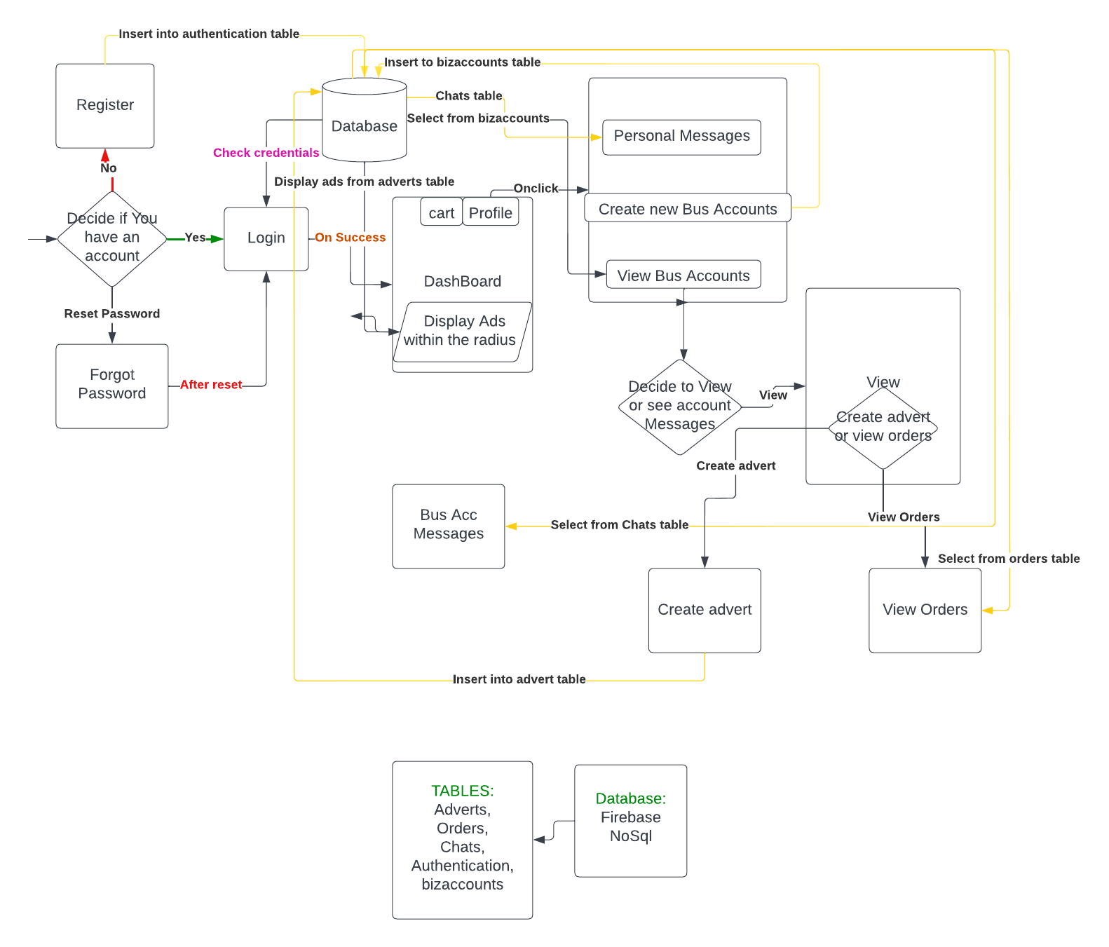

Figure 10 Activity diagram

### 4.4.2 Use case

A use case diagram is a graphical depiction of a user’s possible interactions with a system. It shows various kinds of users that interact with a system and how they interact with the system.

In this case this shows how users who are using this e-commerce application interact directly with the system.e.g by signing up, signing in, reset password, making orders, and chatting with sellers.

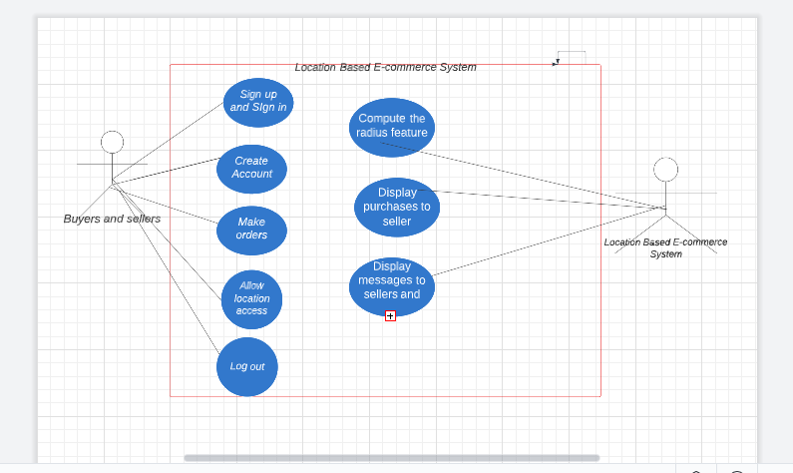

Figure 11 Use case diagram

### Data flow diagram

A data flow diagram is a way of representing a flow of data through a processor system. It also provides information about the outputs and inputs of each entity and the process itself.

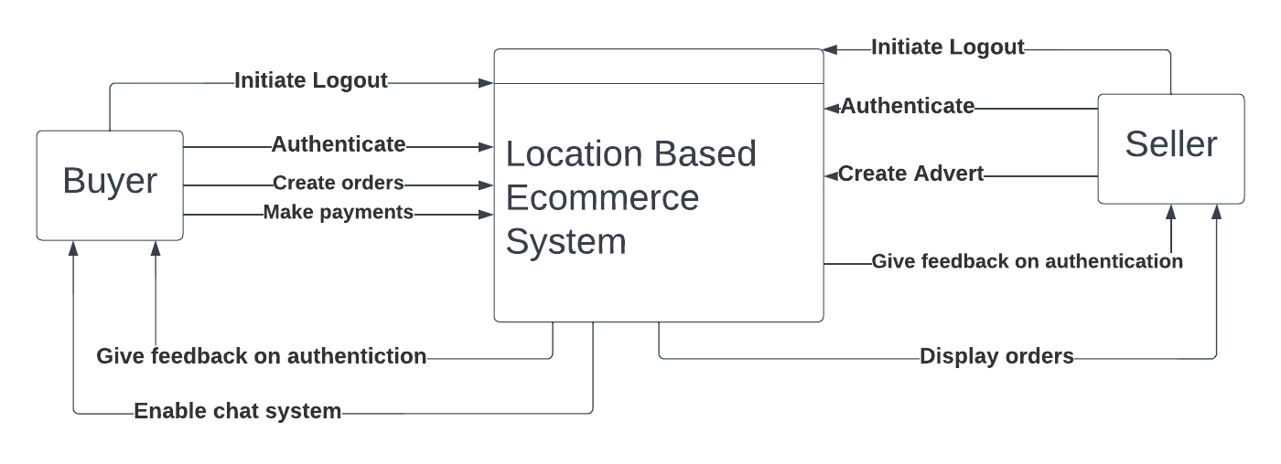

Figure 12 Data Flow Diagram

## 4.5 System Design

System Design is the process of designing the architecture, components, and interfaces for a system so that it meets the end-user requirements.

The major components of this system include:

1. Authentication, this has the sign up section, sign in section, and reset password section.
2. Adverts display section which displays adverts that are within the 3 kilometre radius
3. Business account creation section and advert creation section.
4. The ordering system which enables users to order what they need from the e-commerce system
5. The payment system.

## 4.5.1 Interface Design.

This project was developed with the help of html, CSS, Bootstrap in the front end interface design. The colouring is the CSS properties in the project. Bootstrap is responsible for responsiveness of the website.

### 4.5.1.1 Sign in Page.

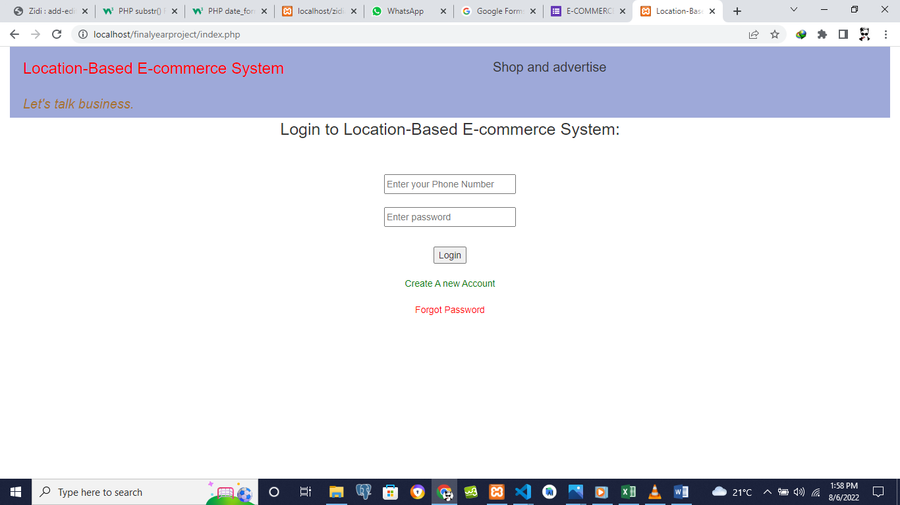

### 4.5.1.2 Sign up Page.

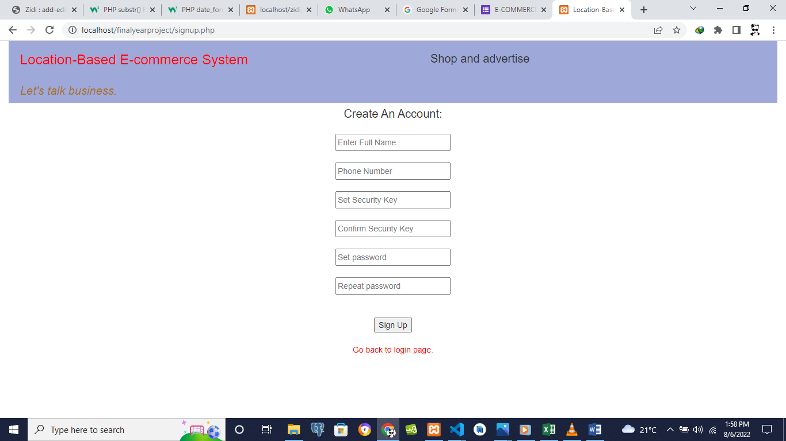

### 4.5.1.3 Reset Page.

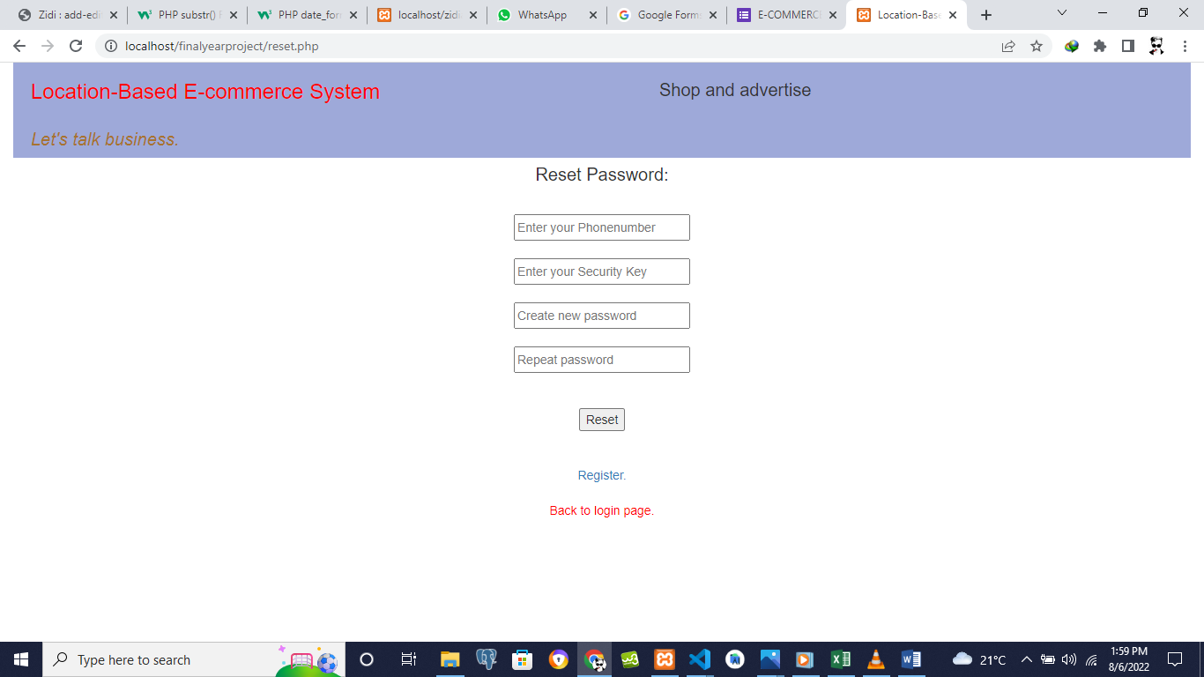

### 4.5.1.4 Home Page.

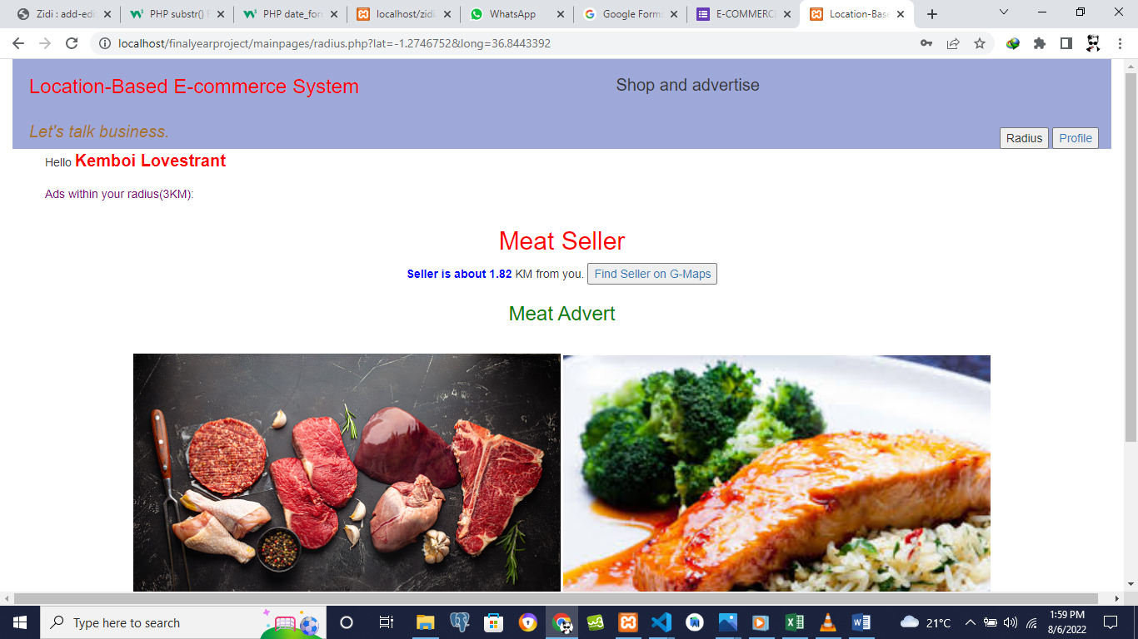

### 4.5.1.5 Profile Page.

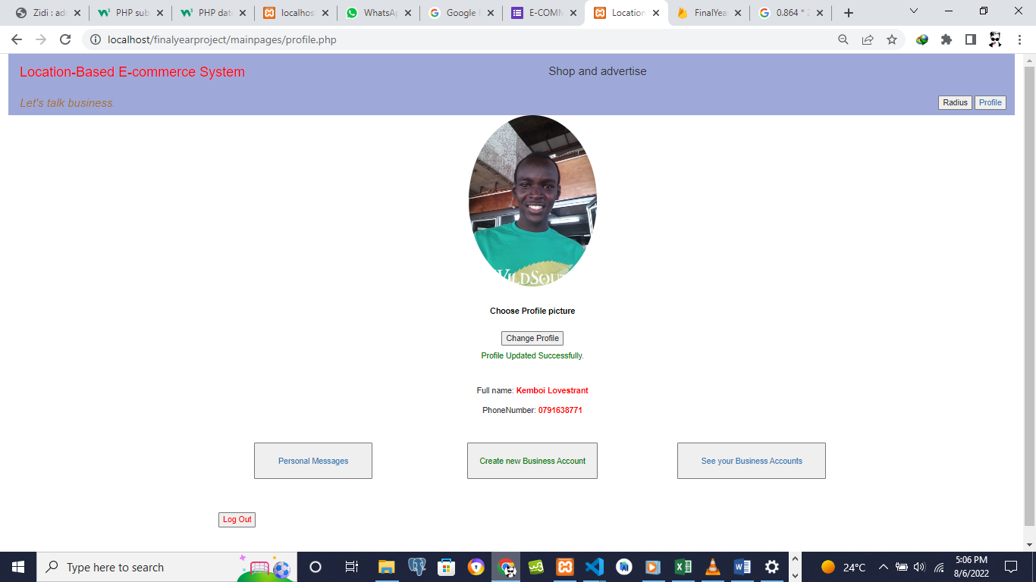

### 4.5.1.6 Create new Business account Page.

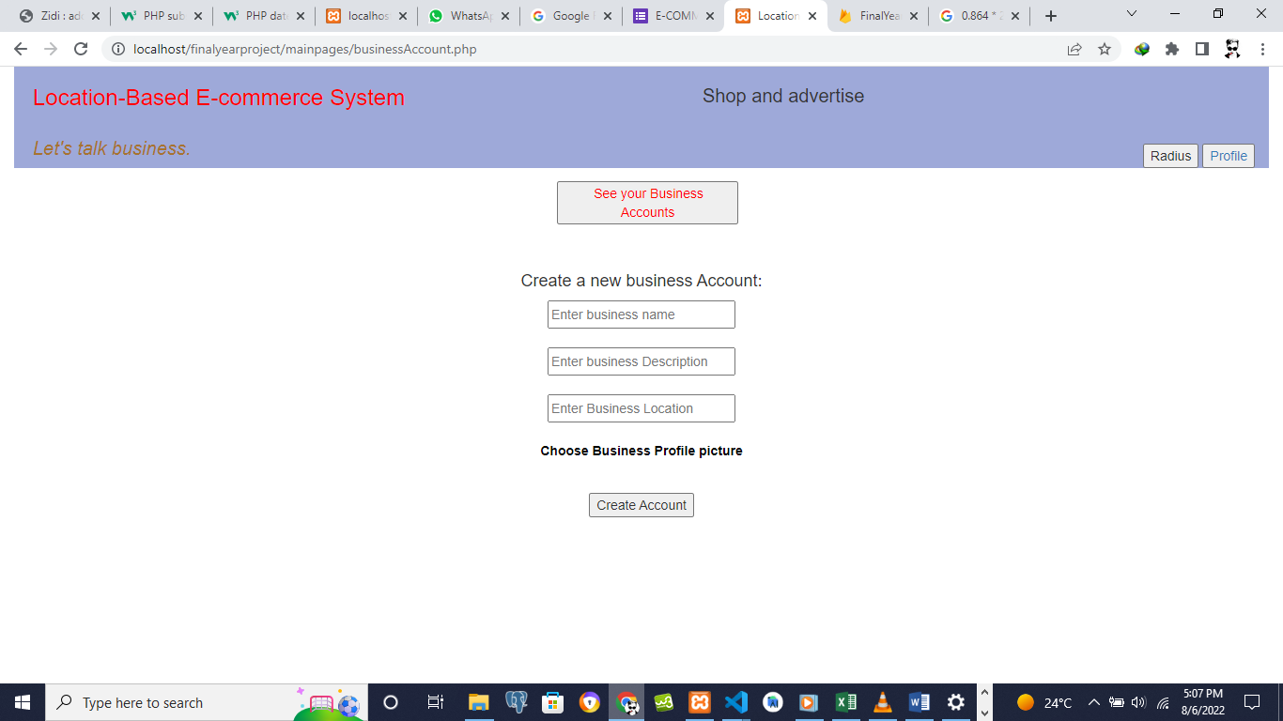

### 4.5.1.7 Business accounts Page.

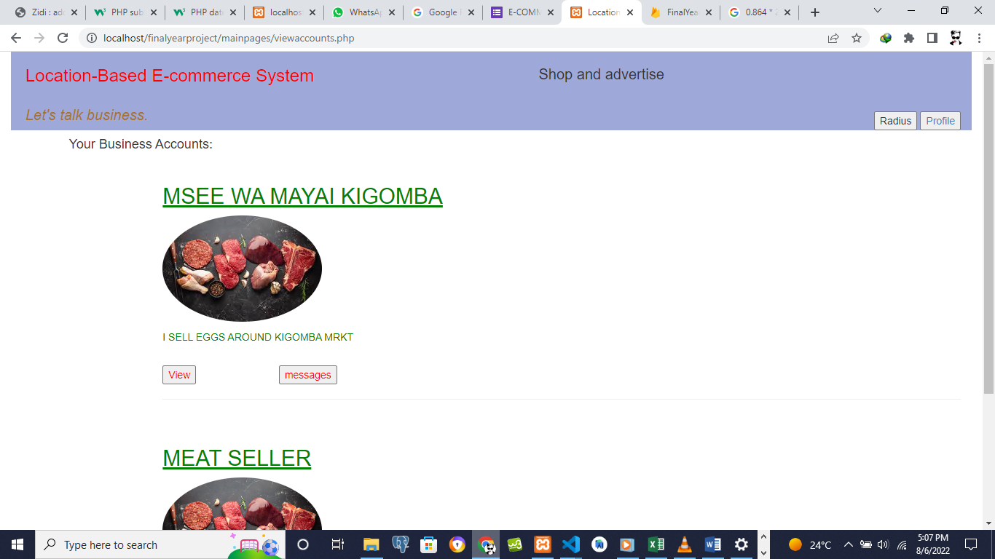

### 4.5.1.8 Advert Creation Page

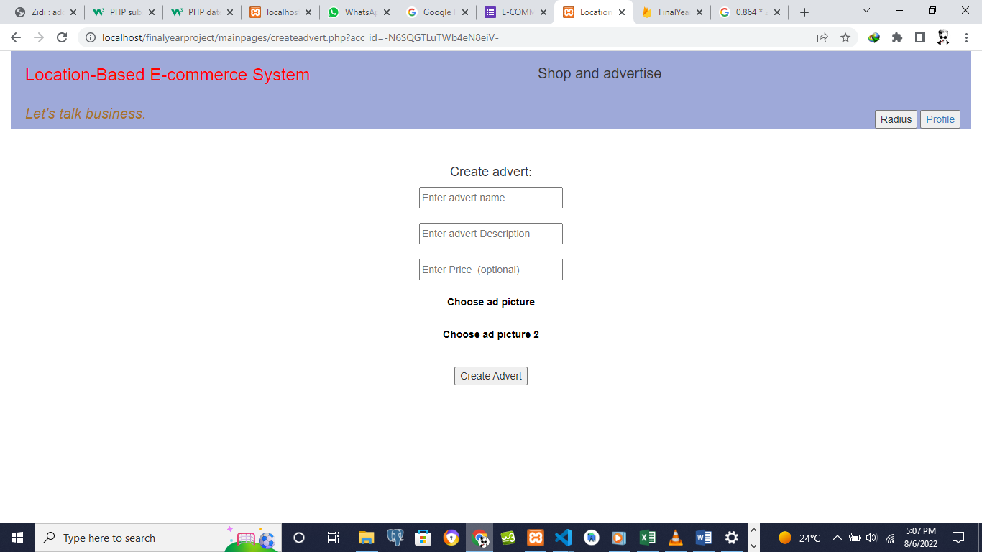

# REFERENCES:

1. Blog on Amazon The giant E-commerce platform in the USA

Retrieved from <https://ecommerce-platforms.com/glossary/amazon>

1. Blog on Alibaba the giant E-commerce platform retrieved from

<https://www.bloomberg.com/quicktake/alibaba#xj4y7vzkg>

1. Article about Jumia one of the giant E-commerce platforms in Kenya, retrieved from

<https://shopinkenya.com/jumia-kenya-understanding-kenyas-largest-e-commerce-platform>